CS 305 Module Two Written Assignment Template

Instructions
Replace the bracketed text with the relevant information in your own words. If you choose to include images or supporting materials, make certain to insert them in all the relevant locations in the document.

Areas of Security
- Input Validation: All input should be validated to help prevent injection attacks. This can be done by validating information in a security system.
- APIs: There is no API key, but if there is proper API endpoint protection it can prevent unauthorized data retrieval or manipulation.
- Cryptography: Necessary to keep the APIs encrypted to prevent unwanted access if used in the program.
- Code Error: Program should have safe exceptions and error handling messages or structures.
- Code Quality: Poorly written code can result in incorrect functionality and introduce sensitive information to attackers. The program can increase its code quality with a more secure parameterized approach.

Areas of Security Justification

- Input Validation is crucial because it can lead to injection attacks, Validation is key to preventing such attacks. APIs will help give proper endpoint protection for the Spring framework and prevent unwanted data retrieval and manipulation within the program. Maybe be necessary to implement a RESTful API, if needs to be accessed outside of system. Cryptography is important when using APIs to protect data and customer information. Software should have proper error handling and should display messages that don’t expose sensitive information. Quality code can prevent data from being introduced to attackers, properly maintained code also prevents operational and logical errors.

Code Review Summary

- Version of spring-data-rest-webmvc: Spring data rest webmvc is dependency on the pom.xml file. An older version of it is being used currently. It uses version 2.6.5, and the newest version 5.0.5 might contain important security updates. Check image #1

- The name parameter directly inputs into the parser.parseExpression(name) on line 27, making it susceptible to injection attacks. Check image #2

- The array used on line 35 might cause an out of bounds exception since it has 7 elements (indexes 0-6). If the user requests 10 or -1 the application might crash. Check image #3

Mitigation Plan
- Spring data rest webmvc dependency version will be updated to the latest version which is 5.0.5
- The Greeting Controllers parser will be updated to include additional input validation. The array should also include some input validation or exception handling before querying it. This will hopefully help secure the code from injection attacks or crashes.

Image #2 pom.xml version

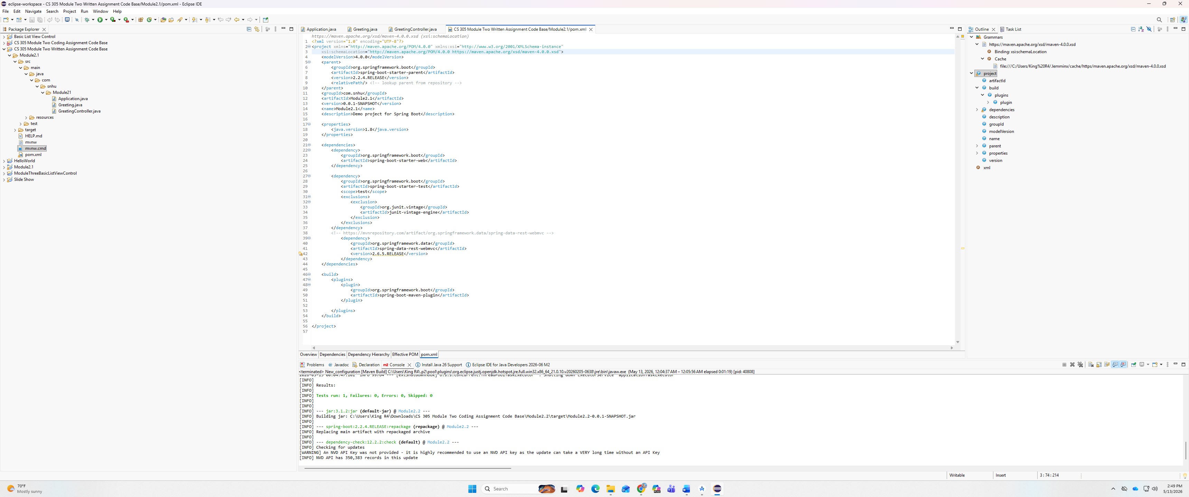
Image #2 GreetingController.java
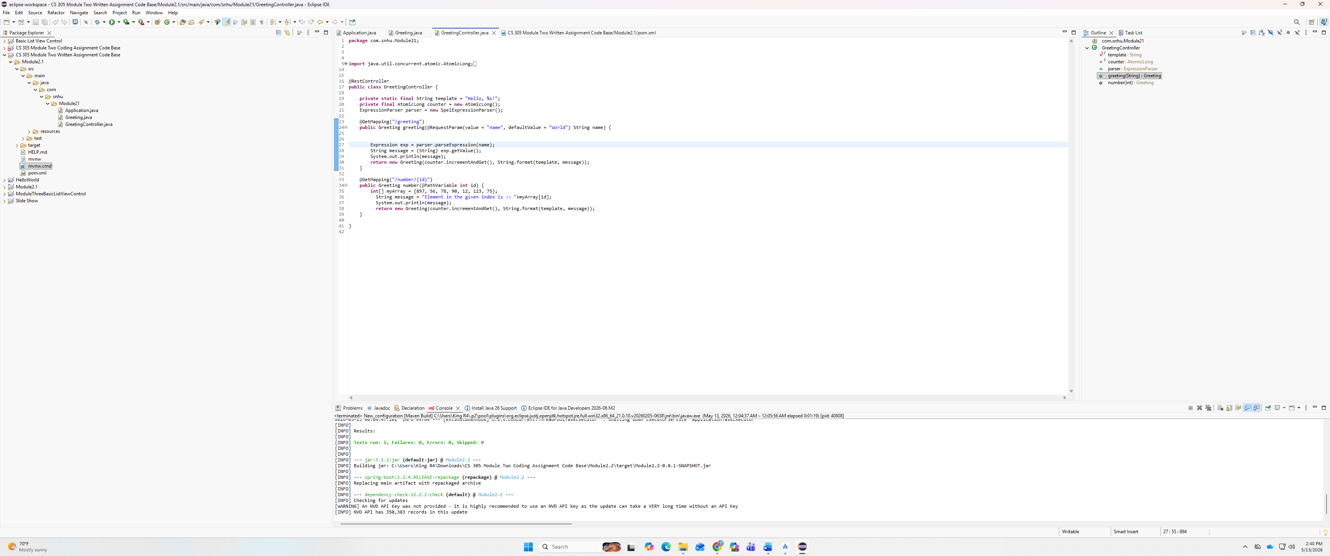

Image #3 GreetingController.java


